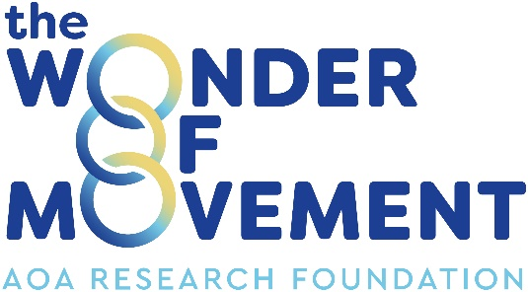

AOA RESEARCH FOUNDATION LIMITED
ABN 94 082 552 574

ANNUAL GENERAL MEETING 2026

Notice of Meeting Agenda

TIME
3.45pm, Wednesday, 14 October 2026

VENUE DETAILS
Cairns Convention Centre and Online
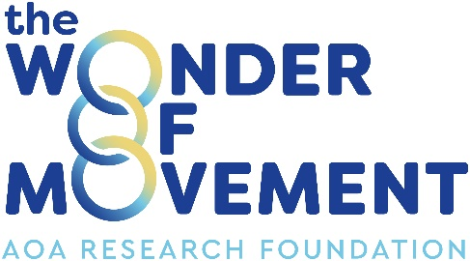

NOTICE OF THE 28th ANNUAL GENERAL MEETING OF
AOA RESEARCH FOUNDATION LIMITED
TO BE HELD ON WEDNESDAY, 14 OCTOBER 2026, at 3:45PM AT CAIRNS CONVENTION CENTRE, CAIRNS AND VIA ONLINE CONFERENCE
(Details available upon registration)

AGENDA

- Welcome, Apologies and Proxies

- Minutes of 2025 Annual General Meeting
If thought fit, resolve that the minutes of the Annual General Meeting held on 15 October 2025 be approved as a correct record of proceedings at that meeting.
- Chair’s Report

- Financial Report, Directors’ Report and Auditor’s Report for 2025/26
To receive and consider the financial statements for the year ended 30 June 2026, and the reports of the Directors and Auditor thereon. If thought fit, resolve that the financial statements for the year ended 30 June 2026 together with the reports of the directors and auditor be approved.

2026 AOARF Fellowship Recipient

Other Business

Adrian Cosenza
Chief Executive Officer and Company Secretary
15 September 2026

Minutes of 2025 Annual General Meeting, Chairman’s Annual Report, Directors’ Report and Financial Report for 2025/26, and Auditors Report for 2025/26 can be downloaded from the AOA website:
www.aoa.org.au > About >Research> Research Foundation > Corporate Documents

Members who wish to have the papers mailed to them should contact AOA: T 02 8071 8000 F 02 8071 8002 E admin@aoa.org.au

A proxy form may be downloaded from the website and must be lodged not less than 48 hours before the time for holding the meeting at the registered office of the foundation,
Level 26, 201 Kent St Sydney NSW 2000 or by fax to 02 8071 8002 or email to research@aoa.org.au

