Hospital Position Logbook Summary
Fellowship Education and Training Spinal Surgery
Australian Orthopaedic Association and Neurosurgical Society of Australasia
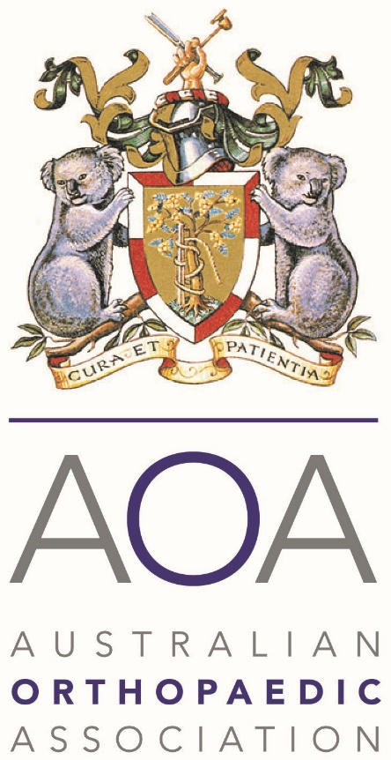


Institution and Chief Supervisor Name : Click or tap here to enter text.
A separate logbook must be completed for each institution related to the proposed position. For each operative case where more than one surgical procedure is undertaken only one procedure may be recorded. Only include cases undertaken by surgeons in the unit who have agreed to participate in the supervision, education and training of the fellow.
Note: Operations with multiple procedures should only be counted once. For example, for a hybrid ACDF and disc arthroplasty, it may be counted as an ACDF or an arthroplasty, but not both.
Spine - Adults and Paediatrics | Year - XXXX
Lumbar discectomy | Click here
Lumbar canal decompression | Click here
Cervical laminectomy | Click here
Cervical foraminotomy | Click here
Thoracic laminectomy | Click here
Thoracic discectomy | Click here
Posterior instrumented fusion, occipito-cervical, cervical, thoracic, lumbar, lumbo-pelvic | Click here
Posterior lumbar fusion without instrumentation | Click here
Anterior cervical discectomy and fusion | Click here
Cervical disc arthroplasty | Click here
Lumbar disc arthroplasty | Click here
Anterior lumbar interbody fusion | Click here
Lateral lumbar interbody fusion | Click here
Posterior lumbar interbody fusion | Click here
Corpectomy and stabilisation | Click here
Epidural abscess | Click here
Epidural haematoma | Click here
Post-operative wound debridement | Click here
Scoliosis | Click here
Sagittal plane deformity | Click here
Pedicle subtraction osteotomy | Click here
Syrinx shunt procedure | Click here
Tethered spinal cord | Click here
Extradural, intradural and intramedullary tumours and lesions of the spine | Click here
Total | Click here
Note: Operations with multiple procedures should only be counted once. For example, for a hybrid ACDF and disc arthroplasty, it may be counted as an ACDF or an arthroplasty, but not both.

