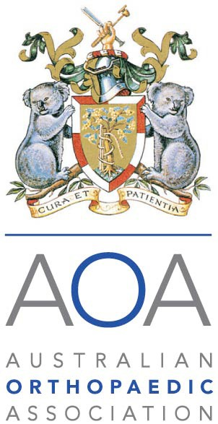
APPLICATION FOR
THE AOA OWL ASM BURSARY

AOA fellows and trainees are invited to apply for the AOA OWL ASM Bursary. Applications must be made in writing using this form and sent via email to owl@aoa.org.au or via post to Australian Orthopaedic Association, Level 26, 201 Kent Street, Sydney NSW 2000.

Applications must meet the eligibility criteria and will be assessed based on the indicated factors. Applicants are asked to provide brief supporting detail on their interest in attending the ASM and how it will benefit them and their practice.

The closing date is 30 June.

I, , being a Trainee/Fellow of the Australian Orthopaedic Association, wish to apply for an AOA OWL ASM Bursary.
I am aware of and meet the eligibility criteria.
I am aware that this bursary covers the full ASM registration and also the named social activities.
Signature |  | Date ______________________________
Supporting detail (please provide below).

