17th February 2014

It’s an absolute pleasure to announce the success of the hard work of NZPOS Haemish Crawford and Michael Bellemore has come to fruition, with the selection of the first POSNA Travelling Fellows to Australasia. The recipients being Noella Larson from the Mayo Clinic in Rochester, Amy McIntosh from Dallas at the Texas Scottish Rite Hospital and Eric Edmonds from Rady Children’s Hospital in San Diego.

A busy and exciting program has been finalised which we’ll see the visitors have the opportunity to go to Perth, Adelaide, Sydney and Melbourne from the 18th May to the 27th May when they head on to New Zealand and then to the Hong Kong Meeting of APPOS. In each state the coordinators of the hosting will be Kate Stannage in Perth, David Little in Sydney and Ian Torode in Melbourne. We will have the opportunity to learn from the travelling fellows in their areas of subspecialty interest as well as be able to showcase the breadth of paediatric orthopaedics at our centres.

I suggest that members of the AOA who are interested in attending the seminars and lecture program contact the local hosts.

.
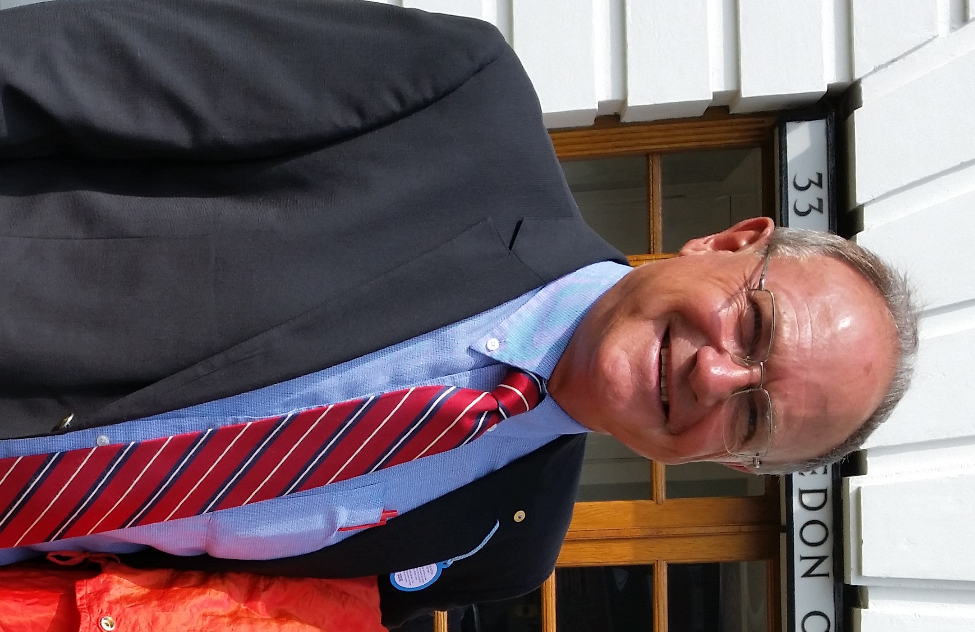

DR BRUCE K FOSTER
PAEDIATRIC ORTHOPAEDIC SURGEON

BKF:MH

